Name: _________________ UCM Student ID: _________________ Catalog Year and Major: ________________

Resources - Click on the url links to browse resources related to:
- Academic Calendar, Dates and Deadlines (https://registrar.ucmerced.edu/schedules/calendars)

- Mandatory Student Requirements and Training (https://ethics.ucmerced.edu/student-requirements)
  - Students are assigned SHAPE training in CATCourses before the start of the semester.
  - Students enrolled for the Fall are required to complete SHAPE training by September 30th.
  - For students starting at UC Merced in the Spring, the deadline is February 28th.

- Academic Support - Library Services (https://library.ucmerced.edu/research/students/new-start-here), Tutoring (https://success.ucmerced.edu/tutoring)
- School of Engineering Website for general information, and the Walk-In and Appointment Schedules (http://engr-advising.ucmerced.edu/see-my-advisor)
- School of Engineering Majors – 4 Year Plans (https://engr-advising.ucmerced.edu/majors)
- School of Engineering Forms (Petition for Program Variance (PPV), Taking Classes at Another Institution, Subsequent Repeat, Excess Unit Appeal, Course Approval) (https://engr-advising.ucmerced.edu/forms)
- Registrar Forms (Major/Minor, Add/Drop, Course Withdrawal, Independent Study, Part Time, Requisite Override, Time Conflict, Intersegmental Cross-Enrollment) (https://registrar.ucmerced.edu/forms)
- School of Natural Sciences Academic Advising: (https://ns-advising.ucmerced.edu/) Forms: (https://ns-advising.ucmerced.edu/forms)

- School of Social Science, Humanities and Arts Academic Advising: (https://ssha-advising.ucmerced.edu/) Forms: (https://ssha-advising.ucmerced.edu/forms)
- Success Anywhere (https://success.ucmerced.edu/) Happening Now, UC Merced News, Student Success Connect Channel, Rufus Bobcat Social Media, Connect with Campus (Campus Events Calendar), (CatLife), Academic Support, Student Life and Engagement, Student Experiences (Community Engagement Center, Study Abroad, UROC, UCDC, UCCS), Health and Wellness (Counseling and Psychological Services (CAPS)), Dean of Students, and Student Resources (Basic Needs, CARE Office, Student Accessibility Services, Office of the Ombuds).

- DATE: Notes:
.

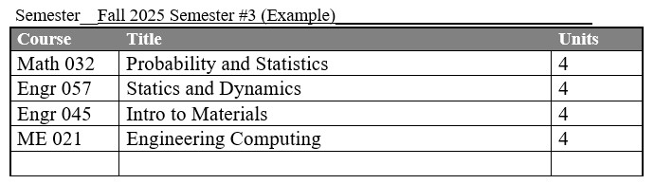

Semester: ___Fall 2025 _______________________________
Course | Title | Units

Semester: ____Spring 2026_____________________________________
Course | Title | Units

Semester: ____Fall 2026_______________________________________
Course | Title | Units

Semester: ___Spring 2027__________________________________
Course | Title | Units

Semester: _____Fall 2027 ____________________________________
Course | Title | Units

Semester: ____Spring 2028___________________________________
Course | Title | Units

Semester: ____Fall 2028____________________________________
Course | Title | Units

Semester: ____Spring 2029 ____________________________________
Course | Title | Units

